SPC Calculations from Settings Chapter
- Set up a Variable within a Variable Group with the data type set as SPC. See the Variable Groups portion of the Settings Chapter.
- Enter in all of the information applicable to the SPC variable (SPC Parameter in previous versions of TME). These are standard entries for SPC data collection. For additional questions on how to set up SPC, contact the TME Administrator.

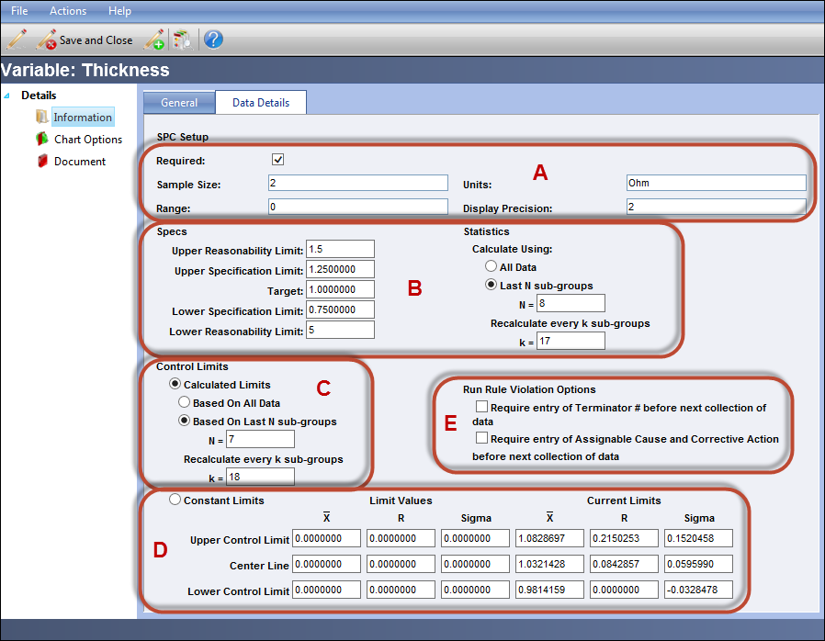
Figure 1 SPC Variable Data Details Screen

Section A

The sample size is the number of points of data to be entered and the Units is the unit of measure taken for the points.

Display Precision defines how many units past the decimal point are to be shown on the chart. For example, a value of two will set the chart to display to the tenths, a value of three will display to the hundredths, etc.

The Range chart automatically calculates the range as the difference between the lowest and highest points for sample sizes greater than one. In this instance, there is no need to input a value into the range field.
When the sample size is “1,” then the Range field needs an input value so that the Moving Range can be calculated.

A typical Moving Range (MR) Chart uses a default value of 2, which means each data point plots the difference (range) between two consecutive data points as they come from the process in sequential order. In the calculation below, the value input into the Range field is represented by the variable m.

Calculation of Moving Range
The difference between data point, , and its predecessor, , is calculated as . For individual values, there are ranges.
Next, the arithmetic mean of these values is calculated as
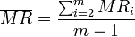
Section B
The Specs fields are used to set the Reasonability and Specification limits as well as the Target. The Specification Limits are also sometimes referred to as Engineering Limits.
The Reasonability limits are set at values for which a point cannot possibly go beyond. For instance, the thickness of an object can’t be less than zero or greater than the height of the mold. Whereas the specification limits are the allowable deviations from the target, i.e., what is an acceptable measurement below or above the target value.
The Statistics fields are used to set up how often the cp and cpk values are recalculated and for how many sample points.
Select either All Data or Last N sub-groups. If calculating off of a portion, then enter the value of N as the number of most recent consecutive samples by which to have TME make the calculation. For example, if 25 is entered, the cp and cpk values will recalculate using the last 25 samples.
Set how often the calculations are to take place (whether with All Data or Last N subgroups) by entering a value for k for Recalculate ever k sub-groups. For example, if 25 is entered, the cp and cpk values will recalculate ever 25th sample.
The values for N and k do not need to be identical.
Definitions for cp and cpk per Wikipedia.org:
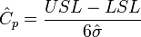 | Estimates what the process is capable of producing if the process mean were to be centered between the specification limits. Assumes process output is approximately normally distributed.
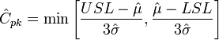 | Estimates what the process is capable of producing, considering that the process mean may not be centered between the specification limits. (If the process mean is not centered, overestimates process capability.) if the process mean falls outside of the specification limits. Assumes process output is approximately normally distributed.
Section C

The Control Limits can be set to Calculate automatically in Section C or defined as constants in Section D. Control Limits are calculated by TME at three standard deviations from the mean in either direction. The closer the samples are to the target, the tighter the control limits and the more stable the process is. When samples go beyond the control limits, that usually signifies that the process is not consistent.

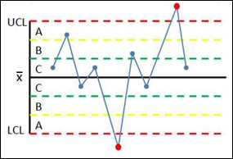
Figure 2 Example of Charted Control Limits

 Each zone (A, B, and C) is one standard deviation from
the target (), the control limits are three standard
deviations from the target.

For statistics and control limits, TME calculates standard deviation as: 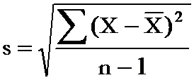 for all points until point #32. Then it switches to dividing by n instead of n – 1.

If TME is to calculate them automatically, select the Calculated Limits radial button. As with the Statistics settings from Section B, set whether the calculations are based on All Data, a portion of the data (put in value for N) as well as how often the Control Limits are to be recalculated (put in a value for k).

Section D

If the Control Limits are to be set at constant levels, select the Constant Limits radial button. Enter Limit Values for the Upper and Lower Control Limits as well as the Center Line (usually the Target from Section B) for Xbar (the calculated mean of the sample points). Enter the Control Limits for R (the Range).

The fields for the Current Limits will populate once data has been collected and will reflect the current limits—if the Control Limits were set up as constant, then they will match the Limit Values from this section. Otherwise, they will represent the calculated Control Limits as set up in Section C.

Section E

The Run Rule Violation Options when set require that certain actions be taken once a violation has occurred.

The first checkbox, requires the entry of a Terminator # before the next collection of data can be made. If it is not provided, the caption for the variable on the data entry screen will be in red font and the fields disabled so that values can’t be entered. The Operator must open the chart and the point’s detail screen and type in the Terminator # (these are defined by the User’s organization, not MASS Group). If the User tries to submit without providing data, a popup screen will appear notifying the User what must be done. See Appendix 7: OCAP for more information regarding Terminator #s.

The second checkbox is similar to the first; it requires that Assignable Cause and Correct Action fields are filled in before the next collection of data can be made.

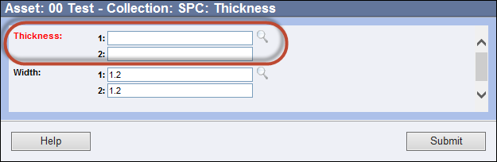
Figure 3 Highlighting Caption to Show Requirement(s) Need to Be Met

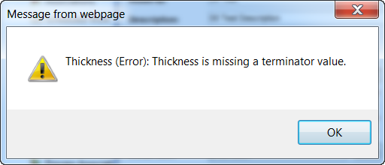
Figure 4 Error Screen Describing Requirements Needed to Continue Data Collection

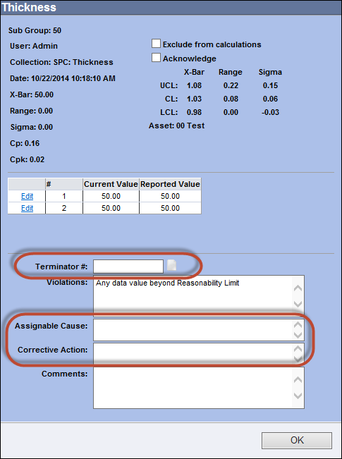
Figure 5 Point Detail Screen - Required Field(s) Highlighted

Chart Options

The link for Chart Options will appear once the Variable has been saved the first time. This screen represents the set up options for the actual chart itself.

If the scale of the y-axis is to be set to always include all points on the chart, no matter how high above or below the target, select Auto Scale. Otherwise, select Fixed Scale and enter the High and Low values for the Xbar and R charts. If a point goes beyond scale, lines going to and from the points will be visible from the adjacent point(s), but the point itself will not be visible or accessible for editing.

The options define at what point the Control Limits (whether Constant or Calculated) become visible on the chart.

Hide Control Limits Before Subgroup “10” means that the limits will not be visible until the 10th Sample is entered.

Mimic the Control Limits of SubGroup “15” onto all previous SubGroups means that the Control Limits that are set at the 15th Sample will be applied to all previous Samples regardless of what their Control Limits were.

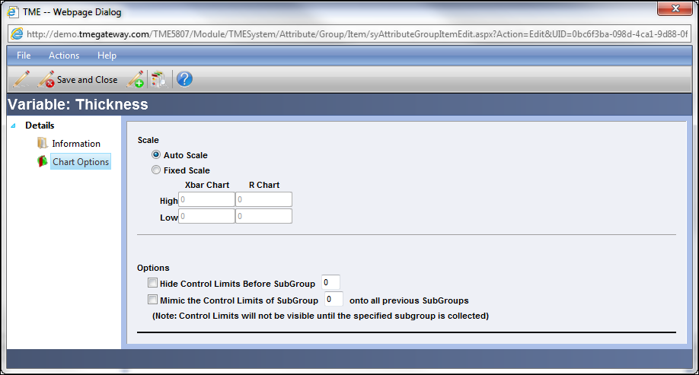
Figure 6 SPC Variable Chart Options Screen

SPC: Basic control charts: theory and construction, sample size, x-bar, r charts, s charts
Authors: Chris Bauman, Jennifer De Heck, Evan Leonard, Merrick MirandaStewards: Eric Black, Stacy Young, Dan Carter, Megan Boekeloo
- Date created: 11/30/06; Revised 11/19/07

Introduction
Control charts are one of the most commonly used methods of Statisical Process Control (SPC), which monitors the stability of a process. The main features of a control chart include the data points, a centerline (mean value), and upper and lower limits (bounds to indicate where a process output is considered "out of control").They visually display the fluctuations of a particular process variable, such as temperature, in a way that lets the engineer easily determine whether these variations fall within the specified process limits. Control charts are also known as Shewhart charts after Walter Shewhart, who developed them in the early 1900’s.

Control Chart Background
A process may either be classified as in control or out of control. The boundaries for these classifications are set by calculating the mean, standard deviation, and range of a set of process data collected when the process is under stable operation. Then, subsequent data can be compared to this already calculated mean, standard deviation and range to determine whether the new data fall within acceptable bounds. For good and safe control, subsequent data collected should fall within three standard deviations of the mean. Control charts build on this basic idea of statistical analysis by plotting the mean or range of subsequent data against time. For example, if an engineer knows the mean (grand average) value, standard deviation, and range of a process, this information can be displayed as a bell curve, or population density function (PDF). The image below shows the control chart for a data set with the PDF overlay.
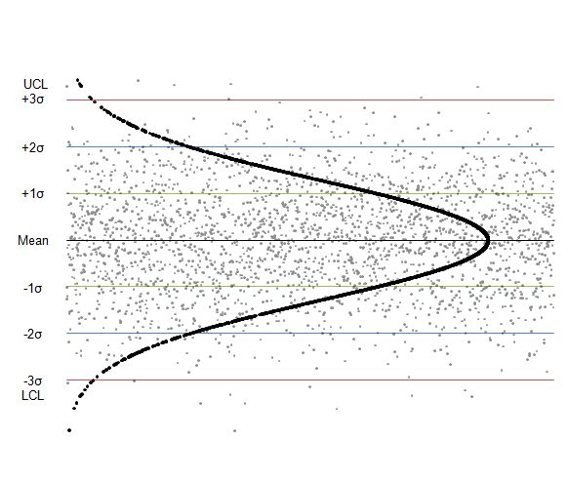
Figure I. Control chart showing PDF for a data set
The centerline is the mean value of the data set and the green, blue and red lines represent one, two, and three standard deviations from the mean value. In generalized terms, if data points fall within three standard deviations of the mean (within the red lines), the process is considered to be in control. These rules are discussed in greater detail later in this section.
Control Charts are commonly used in six sigma control today, as a means of overall process improvement.

Control Chart Functions
The main purpose of using a control chart is to monitor, control, and improve process performance over time by studying variation and its source. There are several functions of a control chart:
1. It centers attention on detecting and monitoring process variation over time.
2. It provides a tool for ongoing control of a process.
3. It differentiates special from common causes of variation in order to be a guide for local or management action.
4. It helps improve a process to perform consistently and predictably to achieve higher quality, lower cost, and higher effective capacity.
5. It serves as a common language for discussing process performance.

Sample Size and Subgrouping
There are a few key conditions that must be met when constructing control charts:
- The initial predictions for the process must be made while the process is assumed to be stable. Because future process quality will be compared to these predictions, they must be based off of a data set that is taken while the operation is running properly.
- Multiple subsets of data must be collected, where a subset is simply a set of n measurements taken over a specific time range. The number of subsets is represented as k. A subset average, subset standard deviation, and subset range will be computed for each subset.
- From these subsets, a grand average, an average standard deviation, and an average range are calculated. The grand average is the average of all subset averages. The average standard deviation is simply the average of subset standard deviations. The average range is simply the average of subset ranges.
The upper and lower control limits for the process can then be determined from this data.
- Future data taken to determine process stability can be of any size. This is because any point taken should fall within the statistical predictions. It is assumed that the first occurrence of a point not falling within the predicted limits shows that the system must be unstable since it has changed from the predictive model.
- The subsets are defined, based on the data and the process. For example, if you were using a pH sensor, the sensor would most likely output pages of data daily. If you know that your sensor has the tendency to drift every day, you might select a 30 minute subset of data. If it drifts monthly you might set your subset to be 24 hours or 12 hours.
- Finally, the population size, N is assumed to be infinite. Alternatively, if the population is finite but the sample size is less than 5% of the population size, we can still approximate the population to be near infinite. That is, n/N <= 0.05 where n is the sample size and N is the population size.

X-Bar, R-Charts, and S-Charts
There are three types of control charts used determine if data is out of control, x-bar charts, r-charts and s-charts. An x-bar chart is often paired with either an r-chart or an s-chart to give a complete picture of the same set of data.
Pairing X-Bar with R-Charts
X-Bar (average) charts and R (range) -charts are often paired together. The X-Bar chart displays the centerline, which is calculated using the grand average, and the upper and lower control limits, which are calculated using the average range. Future experimental subsets are plotted compared to these values. This demonstrates the centering of the subset values. The R-chart plots the average range and the limits of the range. Again, the future experimental subsets are plotted relative to these values. The R-chart displays the dispersion of the subsets. X-Bar/R-Chart plot a subgroup average. Note that they should only be used when subgroups really make sense. For example, in a Gage R&R study, when operators are testing in duplicates or more, subgrouping really represents the same group.
Pairing X-Bar with S-Charts
Alternatively, X-Bar charts can be paired with S-charts (standard deviation). This is typically done when the size of the subsets are large. For larger subsets, the range is a poor statistic to estimate the distributions of the subsets, and instead, standard deviation is used. In this case, the X-Bar chart will display control limits that are calculated using the average standard deviation. The S-Charts are similar to the R-charts; however, instead of the range, they track the standard deviation of multiple subsets.
Reading Control Charts
Control charts can determine whether a process is behaving in an "unusual" way.
Note: The upper and lower control limits are calculated using the grand average and either the average range and average sigma. Example calculations are shown in the Creating Control Charts Section.
The quality of the individual points of a subset is determined unstable if any of the following occurs:
Rule 1: Any point falls beyond 3σ from the centerline (this is represented by the upper and lower control limits).
Rule 2: Two out of three consecutive points fall beyond 2σ on the same side of the centerline.
Rule 3: Four out of five consecutive points fall beyond 1σ on the same side of the centerline.
Rule 4: Nine or more consecutive points fall on the same side of the centerline.
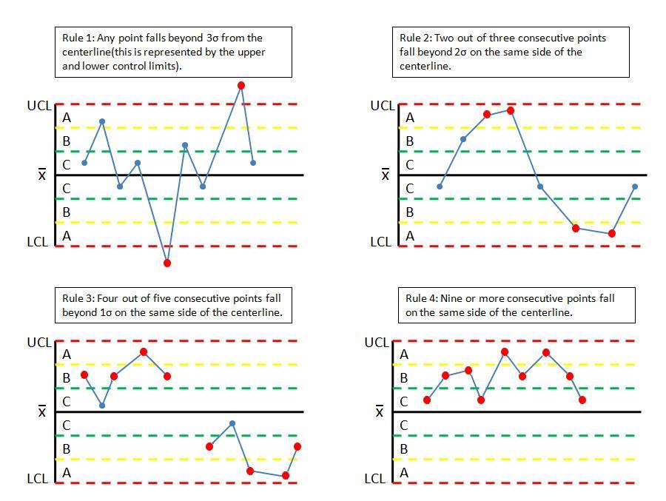
Figure III. Quality control rules.
The quality of a subset is determined unstable according to the following rules:
1. Any subset value is more than three standard deviations from the centerline.
2. Two consecutive subset values are more than two standard deviations from the centerline and are on the same side of the centerline.
3. Three consecutive subset values are more than one standard deviation from the centerline and are on the same side of the centerline.
Creating Control Charts
To establish upper and lower control limits on control charts, there are a number of methods. We will discuss the method for the number of components in a subset, n, less than 15. Here, the table of constants for computing limits, and the limit equations are presented below.
Please note that Table A below does NOT contain data for a sample problem. Any time you make a control chart, you refer to this table. The values in the table are used in the equations for the upper control limit (UCL), lower control limit (LCL), etc. This will be explained in the examples below. If you are interested in how these constants were derived, there is a more detailed explanation in Control Chart Constants.
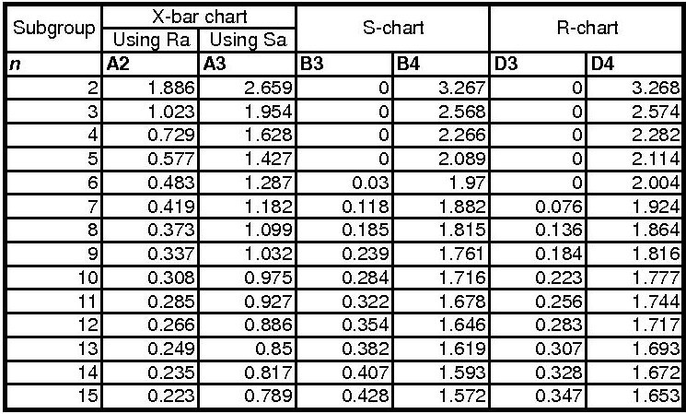
Table A: Table of Constants

To determine the value for n, the number of subgroups
In order to determine the upper (UCL) and lower (LCL) limits for the x-bar charts, you need to know how many subgroups (n) there are in your data. Once you know the value of n, you can obtain the correct constants (A2, A3, etc.) to complete your control chart. This can be confusing when you first attend to create a x-bar control chart. The value of n is the number of subgroups within each data point. For example, if you are taking temperature measurements every min and there are three temperature readings per minute, then the value of n would be 3. And if this same experiment was taking four temperature readings per minute, then the value of n would be 4.
Calculating UCL and LCL
For the X-Bar chart the following equations can be used to establish limits, where is the grand average, is the average range, and is the average standard deviation.
Calculating Grand Average, Average Range and Average Standard Deviation
To calculate the grand average, first find the average of the n readings at each time point. The grand average is the average of the averages at each time point.
To calculate the grand range, first determine the range of the n readings at each time point. The grand range is the average of the ranges at each time point.
To calculate the average standard deviation, first determine the standard deviation of the n readings at each time point. The average standard deviation is the average of the standard deviations at each time point.
Note: You will need to calculate either the grand range or the average standard deviation, not both.
For X-bar charts, the UCL and LCL may be determined as follows:
Alternatively, can be used as well to calculate UCL and LCL:
The centerline is simply .

For R-charts, the UCL and LCL may be determined as follows:
The centerline is the value .

For S-charts, the UCL and LCL may be determined as follows:
The centerline is .
The following flow chart demonstrates the general method for constructing an X-bar chart, R-chart, or S-chart:
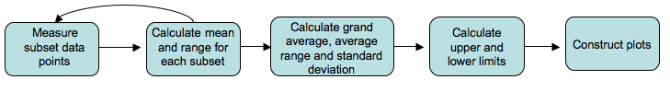
Calculating Region Boundaries
To determine if your system is out of control, you will need to section your data into regions A, B, and C, below and above the grand average. To calculate the boundaries between these regions, you must first calculate the UCL and LCL. The boundaries are evenly spaced between the UCL and LCL. One way to calculate the boundaries is shown below.
Boundary between A and B above X_{GA} = X_{GA} + (UCL − X_{GA}) * 2 / 3
Boundary Between B and C above X_{GA} = X_{GA} + (UCL − X_{GA}) * 1 / 3
Boundary Between A and B below X_{GA} = LCL + (X_{GA} − LCL) * 2 / 3
Boundary Between B and C below X_{GA} = LCL + (X_{GA} − LCL) * 2 / 3

Example 1
Assume that in the manufacture of 1 kg Mischmetal ingots, the product weight varies with the batch. Below are a number of subsets taken at normal operating conditions (subsets 1-7), with the weight values given in kg. Construct the X-Bar, R-charts, and S-charts for the experimental data (subsets 8-11). Measurements are taken sequentially in increasing subset number.
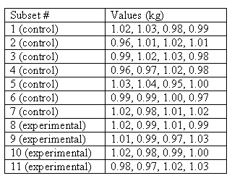
Solution:
First, the average, range, and standard deviation are calculated for each subset.
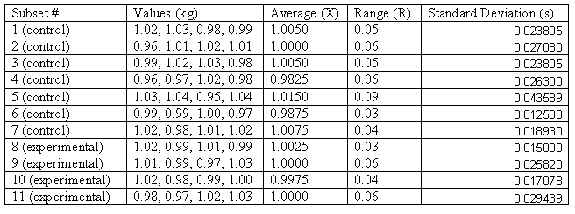
Next, the grand average X_{GA}, average range R_{A}, and average standard deviation S_{A} are computed for the subsets taken under normal operating conditions, and thus the centerlines are known. Here n=4.
X-Bar limits are computed (using ).
X-Bar limits are computed (using ).
Note: Since n=4 (a relatively small subset size), both and can be used to accurately calculate the UCL and LCL.
R-chart limits are computed.
S-chart limits are computed.

The individual points in subsets 8-11 are plotted below to demonstrate how they vary with in comparison with the control limits.
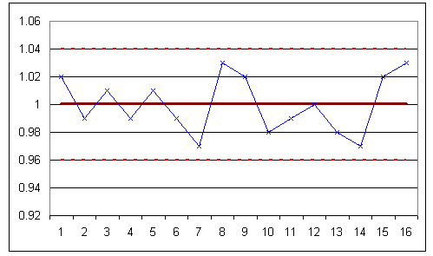
Figure E-1: Chart of individual points in subsets 8-11.
The subgroup averages are shown in the following X-Bar chart:
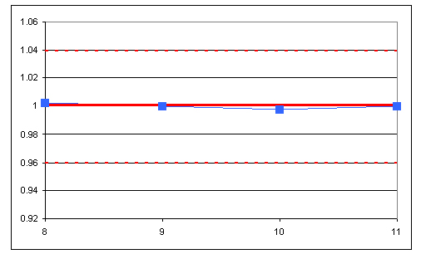
Figure E-2: X-Bar chart for subsets 8-11.
The R-chart is shown below:
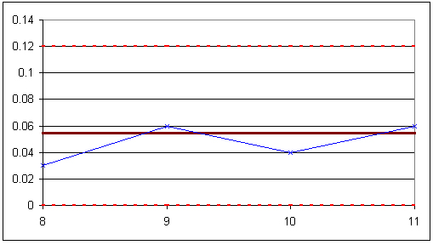
Figure E-3: R-chart for subsets 8-11.
The S-chart is shown below:
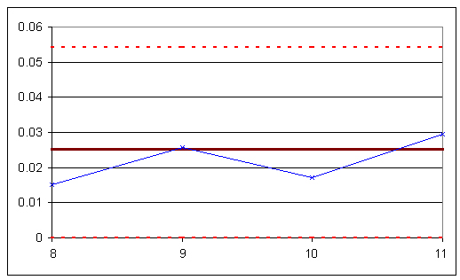
Figure E-4: S-chart for subsets 8-11.
The experimental data is shown to be in control, as it obeys all of the rules given above.

Example 2
It’s your first day on the job as a chemical engineer in a plant, and one of your responsibilities is to monitor the pH of a particular process. You are asked by your boss to monitor the stability of the system. She gives you some baseline data for the process, and you collect data for the process during your first day. Construct X-bar and R-Charts to report your results.
Table 1: Baseline data
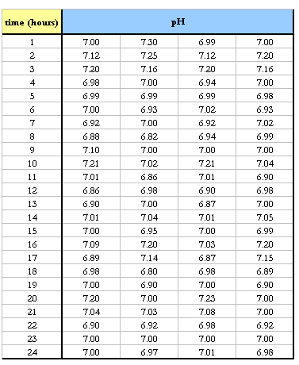
To be consistent with the baseline data, each hour you take four pH readings. The data you collect is displayed below.

Table 2: Experimental data
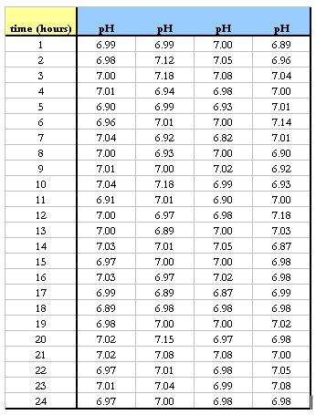
Solution
For this situation, there are k=24 subsets because there are 24 data sets. For each subset, n=4 because there are four pH measurements taken each hour. The first thing you do is calculate the mean and range of each subset. The means are calculated using the AVERAGE() Excel function and the ranges are calculated using MAX() – MIN(). Once these values are calculated, the Grand Average X_{GA} and average range R_{A} are calculated. These values are simply the means of each subset’s mean and range. This data is displayed below.
Table 3: Data used to calculate and grand average and Range.
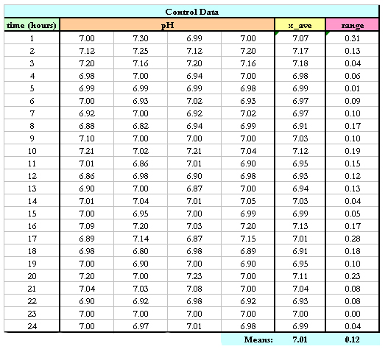
Now that you know X_{GA} = 7.01 and R_{A} = 0.12, you can calculate the upper control limit, UCL, and lower control limit, LCL, for the X-bar control chart.
From Table A, A₂ = 0.729 when n=4. Using equations UCL and LCL for X-bar charts listed above:
Then the UCL = 7.0982, LCL = 6.9251 and X_{GA} = 7.01 are plotted in Excel along with the average values of each subset from the experimental data to produce the X-bar control chart.
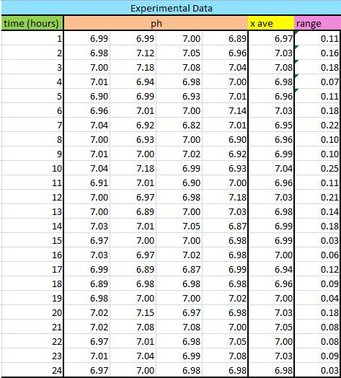
Table 4: Average subset values and ranges plotted on the X-bar and R-chart

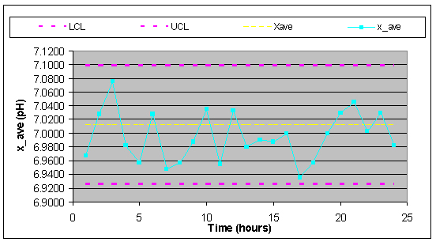
Figure E-5: X-bar control chart

Then, to construct the Range charts, the upper and lower control limits were found. For n=4, D₃ = 0 and D₄ = 2.282 so then:
Then, UCL = 0.2710, LCL = 0, R_{A} = 0.12, and the ranges for each subset were plotted vs. time in Excel (Figure E-6).
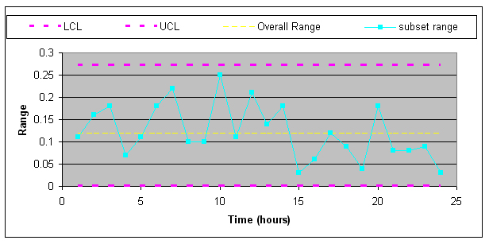
Figure E-6: Range control chart
From both of these charts, the process is in control because all rules for stabilty are met.
Rule 1: No point falls beyond the UCl and LCL.
Rule 2: Two out of three consecutive points do not fall beyond 2σ on the same side of the centerline.
Rule 3: Four out of five consecutive points do not fall beyond 1σ on the same side of the centerline.
Rule 4: Nine or more consecutive points do not fall on the same side of the centerline.
It's important that both of these charts be used for a given set of data because it is possible that a point could be beyond the control band in the Range chart while nothing is out of control on the X-bar chart.
Another issue worth noting is that if the control charts for this pH data did show some points beyond the LCL or UCL, this does not necessarily mean that the process itself is out of control. It probably just means that the pH sensor needs to be recalibrated.

Example 3
A simple out-of-control example with a sample constructed control chart.
You have been analyzing the odd operation of a temperature sensor in one of the plant's CSTR reactors. This particular CSTR's temperature sensor consists of three small thermocouples spaced around the reactor: T1, T2, and T3. The CSTR is jacketed and cooled with industrial water. The reaction taking place in the reactor is moderately exothermic. You know the thermocouples are working fine; you just tested them, but a technician suggests the CSTR has been operating out of control for the last 10 days. There have been daily samples taken and there is a control chart created from the CSTR's grand average and standard deviation from the year's operation.
You are assigned to see if the CSTR is operating out of control. The grand average is 307.47 units of temperature and the grand standard deviation is 4.67 units of temperature. The data is provided for construction of the control chart in Table 1 and the data from the last 10 troublesome days is shown in Table 2. You decide to plot the troublesome data onto the control chart to see if it violates any stability rules.
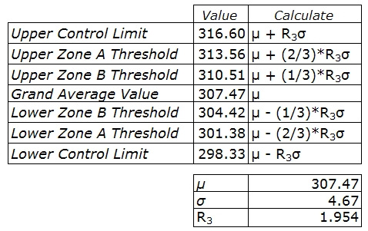
Table 3-1. Data for Construction of Control Chart
The way I found A_3 or in this case, R_3, I used the control charts constants table which is found on this wiki page. I decided to use the x-bar using the standard deviations) but you can also use use the range). I found that the value for n(number of subgroups) is three since the CSTR's temperature sensor consists of three small thermocouples (T1,T2,T3). Therefore by looking at the constant chart, I get A_3( or R_3 in this case) to be 1.954. Here's the table below:
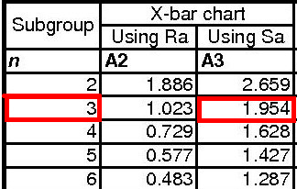
Also, you will notice if you used the range instead of the standard deviation to determine the UCL,LCL, etc. that the values will be roughly the same. Here's the table in comparing the values of UCL and LCL using either A_2 (range) or A_3(stdev):
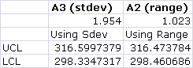
Note: These values were using the same grand average (307.47), the grand standard deviation (4.67) and the grand range (8.80)
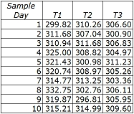
Table 3-2. Sample Data from Past 10 Troublesome Days
Solution
When the sample data was graphed onto the control chart, the image below was seen.
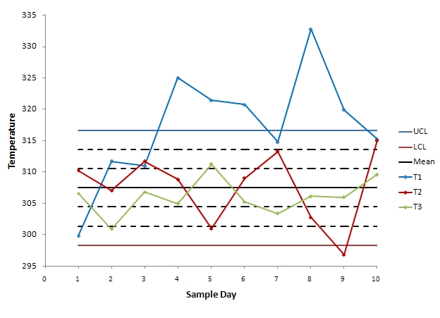
Figure 3-1. 10-Day Data Graphed Onto Control Chart
We can see from the control chart that the CSTR system is clearly out of control. Each thermocouple was tested to see which stability rules it violates.
The first thermocouple (T1) violates every stability rule.
- Rule 1 - Several points from the T1 data fall above the upper control line.
- Rule 2 - There are many instances where at least two out of three consecutive points fall above the zone AB threshold.
- Rule 3 - There are eight consecutive points falling above the BC threshold.
- Rule 4 - Nine consecutive points fall above the mean value.
Judging on this thermocouple's performance, we can say that the system is out of control, but we will analyze the other thermocouples' performance for good measure.
The second thermocouple (T2) violates stability rule 1, 2, and 3.
- Rule 1 - One point falls below the lower control line.
- Rule 2 - Two consecutive points (samples 9 and 10) fall beyond the AB threshold.
- Rule 3 - Of the last five samples from T2, four are beyond the BC threshold.
The third thermocouple (T3) does not violate any stability rules and the results it displays are within control.
This system is out of control because the data from the thermocouples falls beyond the threshold rules for the unit's control chart. This could be explained with many potential situations. One is explained below.
If the CSTR's agitator is knocked loose, the agitation could become erratic. The erratic agitation could create eddy currents and hot spots in the CSTR.
The entire system is out of control because you know that the thermocouples are operating fine and more than one thermocouple violates the stability rules.

Shewhart Individuals Control Chart
From Wikipedia, the free encyclopedia
In statistical quality control, the individual/moving-range chart is a type of control chart used to monitor variables data from a business or industrial process for which it is impractical to use rational subgroups.^{[1]}
The chart is necessary in the following situations:
- Where automation allows inspection of each unit, so rational subgrouping has less benefit.
- Where production is slow so that waiting for enough samples to make a rational subgroup unacceptably delays monitoring
- For processes that produce homogeneous batches (e.g., chemical) where repeat measurements vary primarily because of measurement error
The "chart" actually consists of a pair of charts: one, the individuals chart, displays the individual measured values; the other, the moving range chart, displays the difference from one point to the next. As with other control charts, these two charts enable the user to monitor a process for shifts in the process that alter the mean or variance of the measured statistic.

Calculation of moving range
The difference between data point, , and its predecessor, , is calculated as . For individual values, there are ranges.
Next, the arithmetic mean of these values is calculated as
If the data are normally distributed with standard deviation then the expected value of is

Calculation of moving range control limit[edit]
The upper control limit for the range (or upper range limit) is calculated by multiplying the average of the moving range by 3.267:
.
The value 3.267 is taken from the sample size-specific D₄ anti-biasing constant for n=2, as given in most textbooks on statistical process control (see, for example, Montgomery^{[2]:725}).

Calculation of individuals control limits[edit]
First, the average of the individual values is calculated:
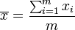.
Next, the upper control limit (UCL) and lower control limit (LCL) for the individual values (or upper and lower natural process limits) are calculated by adding or subtracting 2.66 times the average moving range to the process average:
The value 2.66 is obtained by dividing 3 by the sample size-specific d₂ anti-biasing constant for n=2, as given in most textbooks on statistical process control (see, for example, Montgomery^{[2]:725}).

